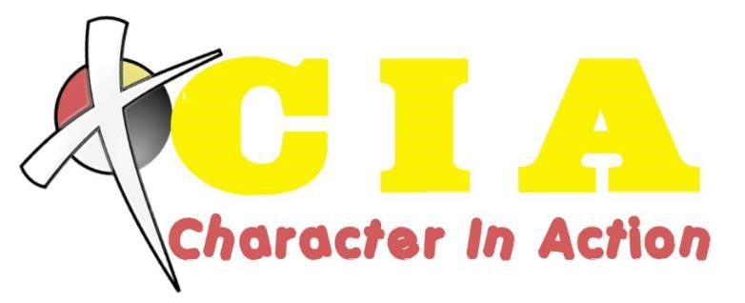

**2025/2026 Theme Nights and Events Calendar**

|  |  |  |  |  |  |
| --- | --- | --- | --- | --- | --- |
| **Date** | **Theme**/**Event** |  |  |  |  |
| Aug 27 | Ice Cream Social | ---------------------------------------------- |  |  |  |
| Sep 3 | Bible Clue Scavenger Hunt | (Lesson 1: Joyfulness) |  |  |  |
| Sep 10 | Boot Camp Night | (Lesson 2: Joyfulness) |  |  |  |
| Sep 17 | Survival Night | ---------------------------------------------- |  |  |  |
| Sep 24 | Blacklight Space Night | (Lesson 3: Joyfulness) |  |  |  |
| Oct 1 | OCC Penny Drive Night | (Lesson 4: Joyfulness) |  |  |  |
| Oct 8 | Class Color Night | (Lesson 5: Peacefulness) |  |  |  |
| Oct 15 | Bring a Parent to Game Night/CIA Store | (Lesson 6: Peacefulness) |  |  |  |
| Oct 22 | Noah’s Ark Night – earn double points! | (Lesson 7: Peacefulness) |  |  |  |
| Oct 29 | Paper Airplane Night | (Lesson 8: Peacefulness) |  |  |  |
| Nov 5 | Veterans Night | (Lesson 9: Patience) |  |  |  |
| Nov 12 | Operation Christmas Child Night | (Lesson 10: Patience) |  |  |  |
| Nov 19 | U Can if U Care: Canned Food Drive | (Lesson 11: Patience) |  |  |  |
| Nov 26 | Thanksgiving Break (no club) | ---------------------------------------------- |  |  |  |
| Dec 3 | Make A Snowman Night | (Lesson 12: Patience) |  |  |  |
| Dec 10 | Ugly Sweater Night/ CIA Store | (Lesson 13: Compassion) |  |  |  |
| Dec 17 | CIA Christmas Party | ---------------------------------------------- |  |  |  |
| Dec 24 | Christmas Break (no club) | ---------------------------------------------- |  |  |  |
| Dec 31 | New Year’s Break (no club) | ---------------------------------------------- |  |  |  |
| Jan 7 | Pajamas & Popcorn Q & A Night | (Lesson 14: Compassion) |  |  |  |
| Jan 14 | Crazy Sock Night | (Lesson 15: Compassion) |  |  |  |
| Jan 21 | Hawaiian Night | (Lesson 16: Compassion) |  |  |  |
| Jan 28 | FYND Out Free Clinic Diaper Drive | (Lesson 17: Forgiveness) |  |  |  |
| Feb 4 | Bible Heroes Night | (Lesson 18: Forgiveness) |  |  |  |
| Feb 11 | ‘Tis So Sweet to Trust in Jesus Night | (Lesson 19: Forgiveness) |  |  |  |
| Feb 18 | CIA Store | (Lesson 20: Forgiveness) |  |  |  |
| Feb 25 | Under the Sea Night | (Lesson 21: Loyalty) |  |  |  |
| Mar 4 | Serving Parents Night | -------------------------------------------- |  |  |  |
| Mar 11 | Spring Break |  |  |  |  |
| Mar 18 | Blacklight Night | (Lesson 22: Loyalty) |  |  |  |
| Mar 25 | Extra Fun Game Night | (Lesson 23: Loyalty) |  |  |  |
| Apr 1 | Easter Break | ----------------------------------------------------- |  |  |  |
| Apr 8 | Secret Agent Night | (Lesson 24: Loyalty) |  |  |  |
| Apr 15 | CIA Store | (Finish Book Work) |  |  |  |
| Apr 22 | -----------------------------Closing Ceremony----- | ----------------------------------------------------- |  |  |  |

**Special TCANP Family Events:**

Harvest Party, October 31,

Grand Prix, March TBD

Brown = Outdoor event

Blue = Clubber participation opportunity (Theme dress up, etc.)

Green = Missions/Community Outreach Donations

Red = No Club

Purple = Special CIA Events